Module 7 Note

##Overview

(As captured from Data Bootcamp Module 7)

I am the assigned Data Analyst assisting Bobby an HR analyst whose task is to perform employee research. As the Data Analyst, I will be applying my knowledge of DataFrames and tabular data, you'll create entity relationship diagrams (ERDs), import data into a database, troubleshoot common errors, and create queries that use data to answer questions.

By the end of this module, as assigned Data Analyst, I will complete the following::

* Design an ERD that will apply to the data.
* Create and use a SQL database.
* Import and export large CSV datasets into pgAdmin.
* Practice using different joins to create new tables in pgAdmin.
* Write basic- to intermediate-level SQL statements.

##Purpose

### Instructions

#### Deliverable 1: The Number of Retiring Employees by Title (50 points)

Using the ERD you created in this module as a reference and your knowledge of SQL queries, create a Retirement Titles table that holds all the titles of employees who were born between January 1, 1952 and December 31, 1955. Because some employees may have multiple titles in the database—for example, due to promotions—you’ll need to use the DISTINCT ON statement to create a table that contains the most recent title of each employee. Then, use the COUNT() function to create a table that has the number of retirement-age employees by most recent job title. Finally, because we want to include only current employees in our analysis, be sure to exclude those employees who have already left the company.

Create a SQL file in the Queries folder of your Pewlett-Hackard-Analysis GitHub folder, and name it Employee_Database_challenge.sql.

create a Retirement Titles table that holds all the titles of employees who were born between January 1, 1952 and December 31, 1955.

Follow the instructions below to complete Deliverable 1.

1. Retrieve the emp_no, first_name, and last_name columns from the Employees table.
2. Retrieve the title, from_date, and to_date columns from the Titles table.
3. Create a new table using the INTO clause.
4. Join both tables on the primary key.
5. Filter the data on the birth_date column to retrieve the employees who were born between 1952 and 1955. Then, order by the employee number.

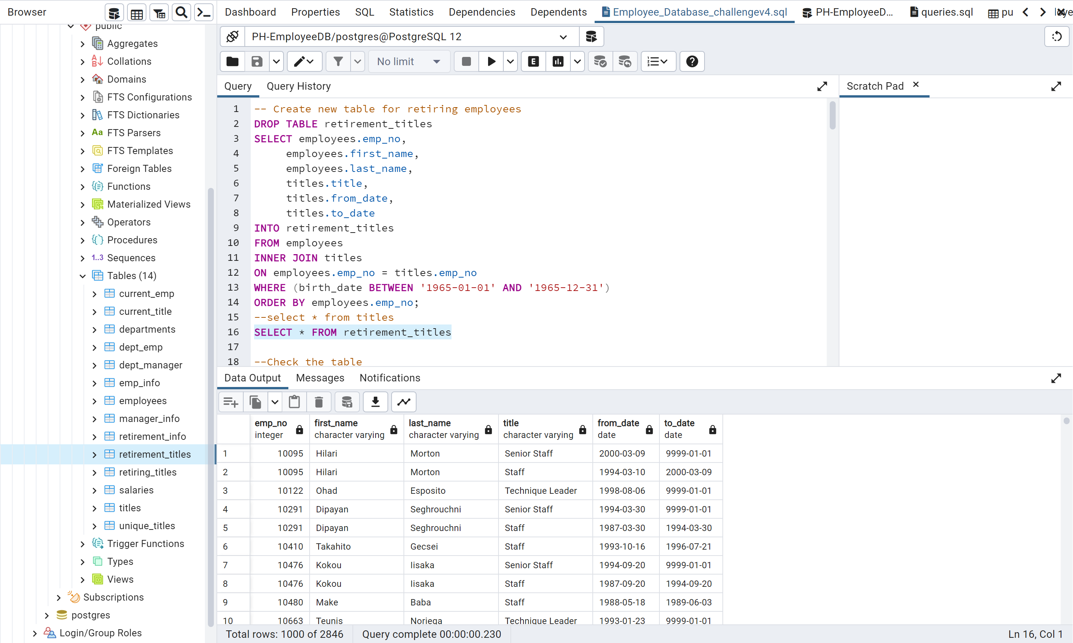

1. Export the Retirement Titles table from the previous step as retirement_titles.csv and save it to your Data folder in the Pewlett-Hackard-Analysis folder.

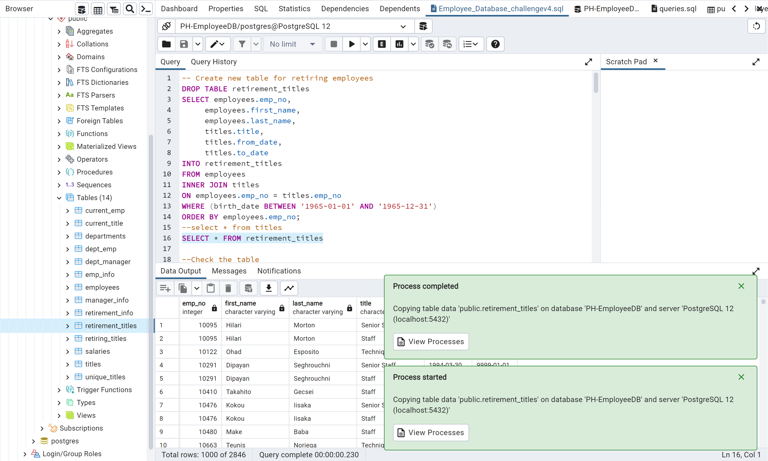

1. Copy the query from the Employee_Challenge_starter_code.sql and add it to your Employee_Database_challenge.sql file.
2. Retrieve the employee number, first and last name, and title columns from the Retirement Titles table.
   * These columns will be in the new table that will hold the most recent title of each employee.
   * *Exported the “Current Titles.csv “and saved to Data folder in the Pewlett-Hackard-Analysis folder.*

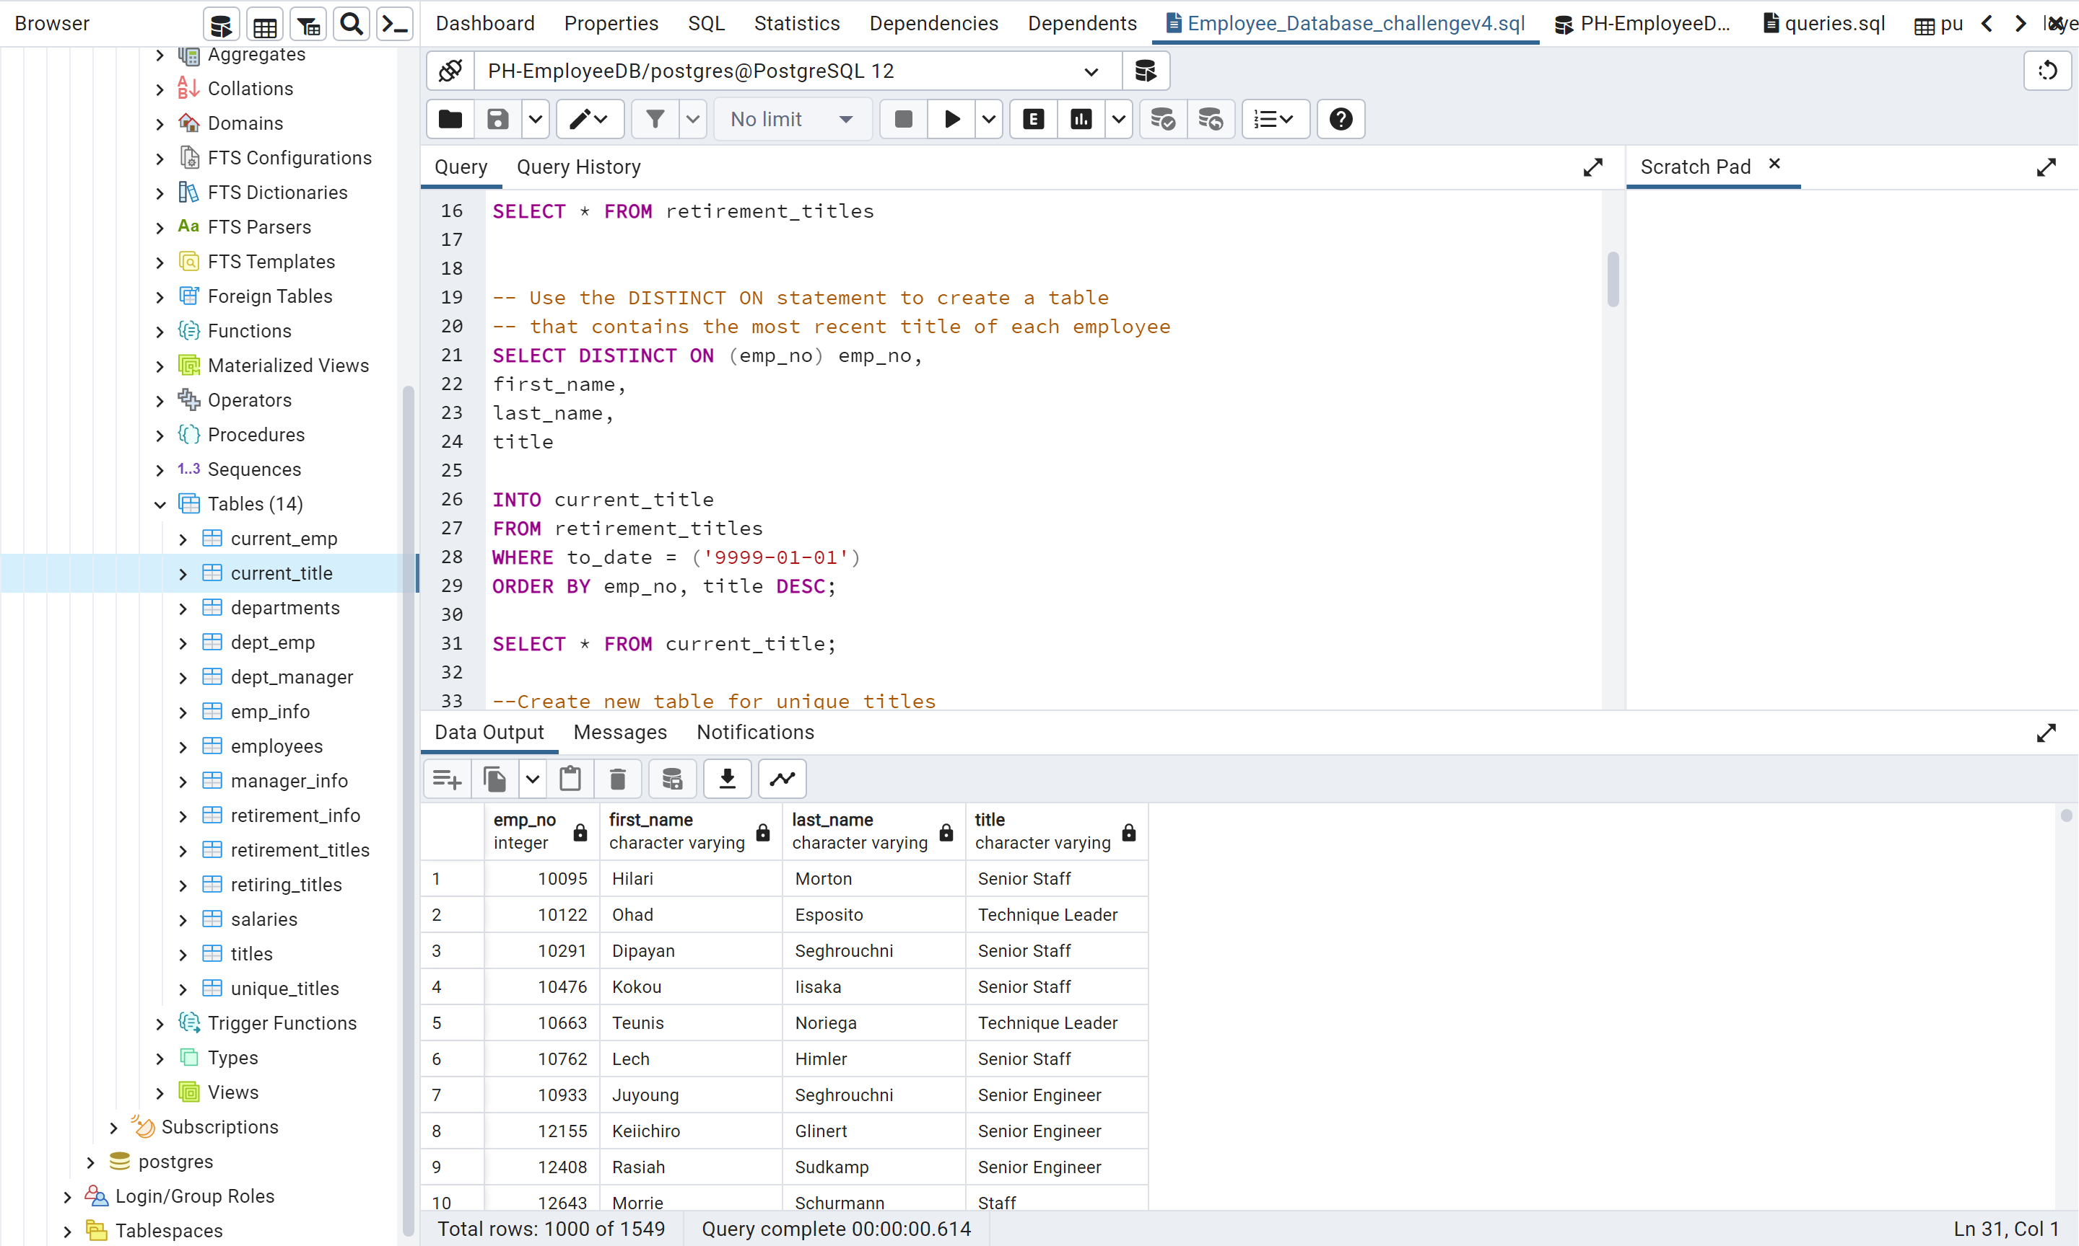

1. Use the DISTINCT ON statement to retrieve the first occurrence of the employee number for each set of rows defined by the ON () clause.
2. Exclude those employees that have already left the company by filtering on to_date to keep only those dates that are equal to '9999-01-01'.
3. Create a Unique Titles table using the INTO clause.
4. Sort the Unique Titles table in ascending order by the employee number and descending order by the last date (i.e., to_date) of the most recent title.
5. Export the Unique Titles table as unique_titles.csv and save it to your Data folder in the Pewlett-Hackard-Analysis folder.

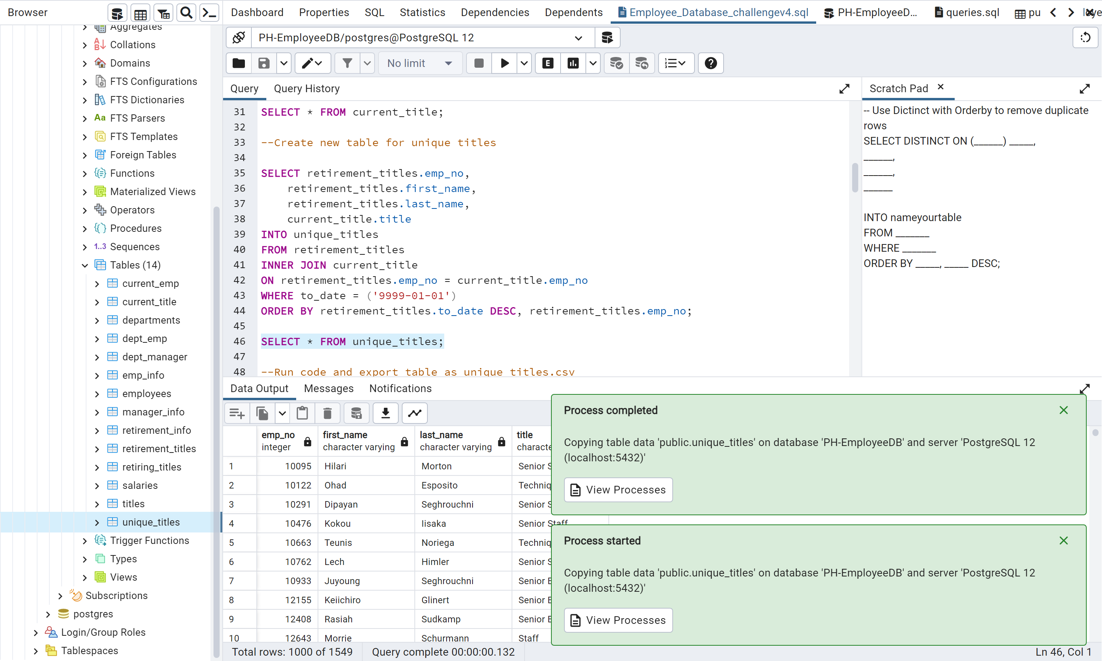

1. Write another query in the Employee_Database_challenge.sql file to retrieve the number of employees by their most recent job title who are about to retire.
2. First, retrieve the number of titles from the Unique Titles table.

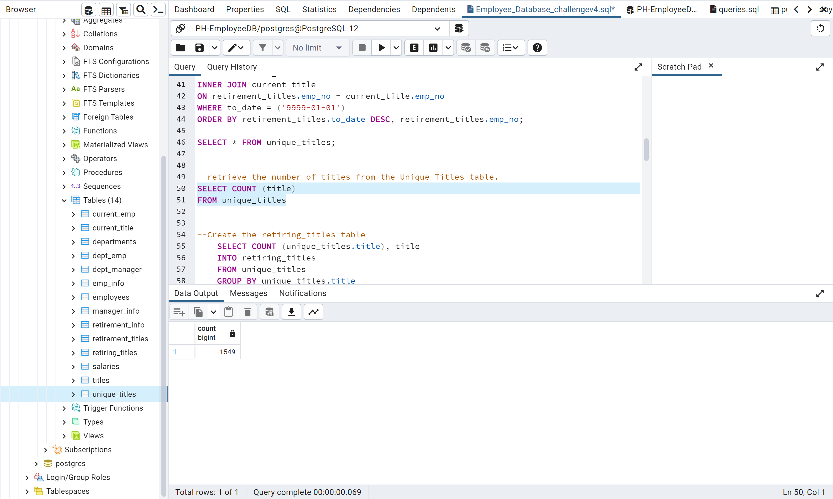

1. Then, create a Retiring Titles table to hold the required information.
2. Group the table by title, then sort the count column in descending order.

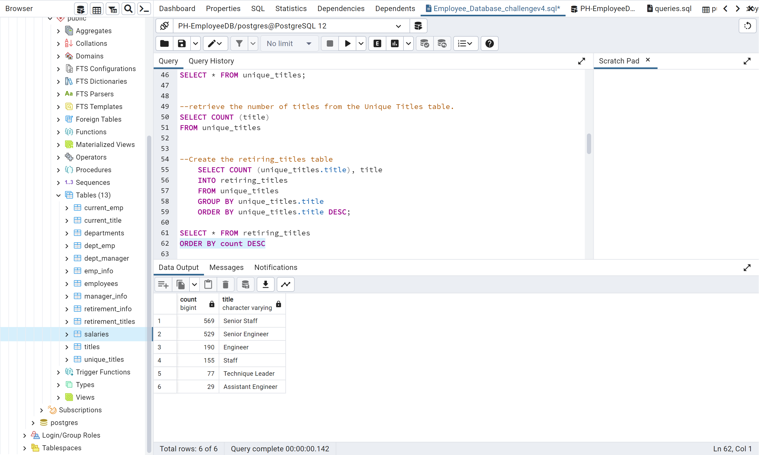

1. Export the Retiring Titles table as retiring_titles.csv and save it to your Data folder in the Pewlett-Hackard-Analysis folder.

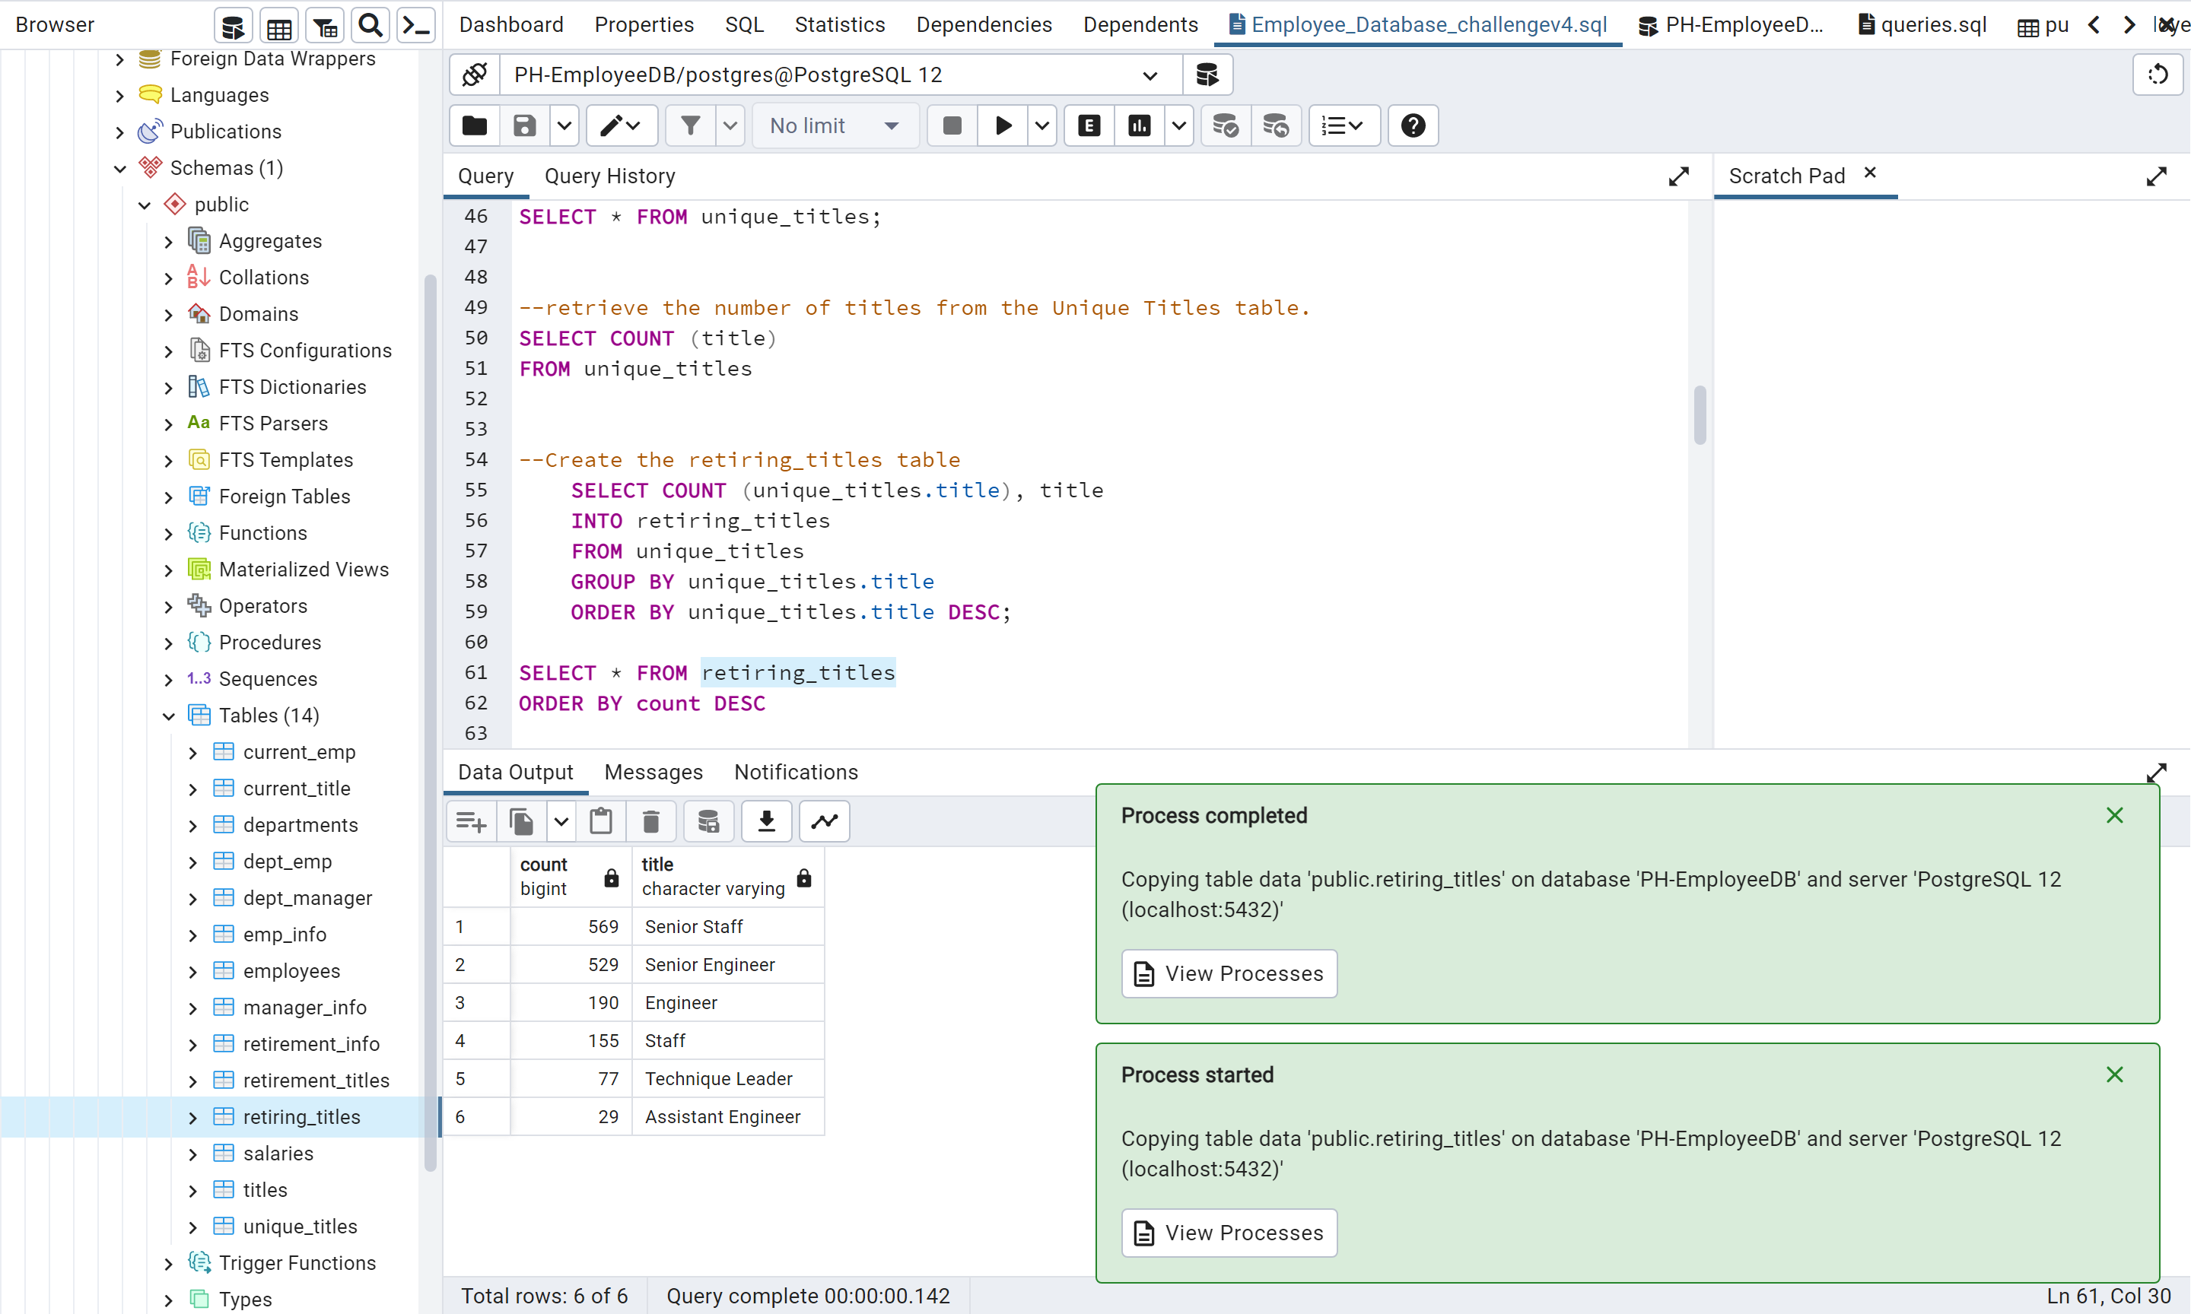

1. Save your Employee_Database_challenge.sql file in your Queries folder in the Pewlett-Hackard folder.

#### Deliverable 2: The Employees Eligible for the Mentorship Program

In the Employee_Database_challenge.sql file, write a query to create a Mentorship Eligibility table that holds the employees who are eligible to participate in a mentorship program.

1. Retrieve the emp_no, first_name, last_name, and birth_date columns from the Employees table.
2. Retrieve the from_date and to_date columns from the Department Employee table.
3. Retrieve the title column from the Titles table.

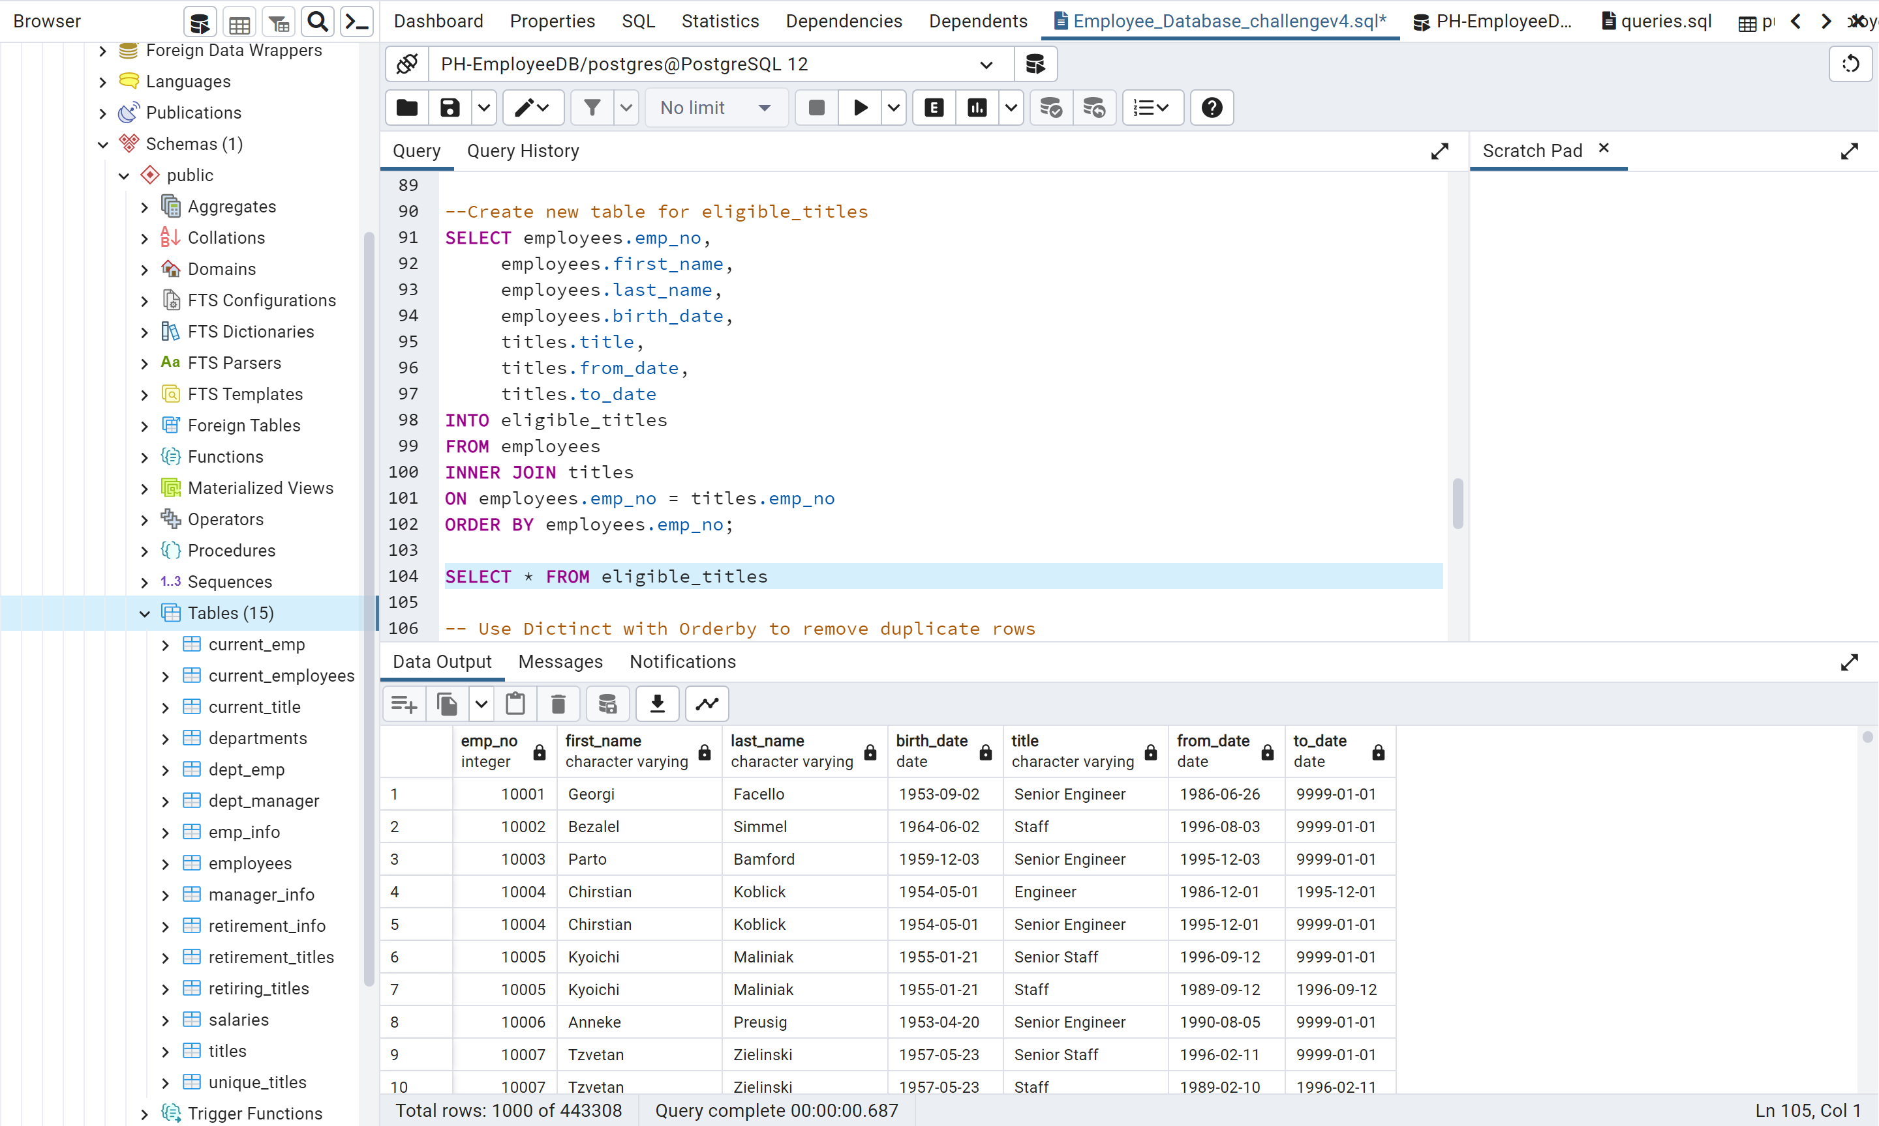

1. Use a DISTINCT ON statement to retrieve the first occurrence of the employee number for each set of rows defined by the ON () clause.
2. Create a new table using the INTO clause.

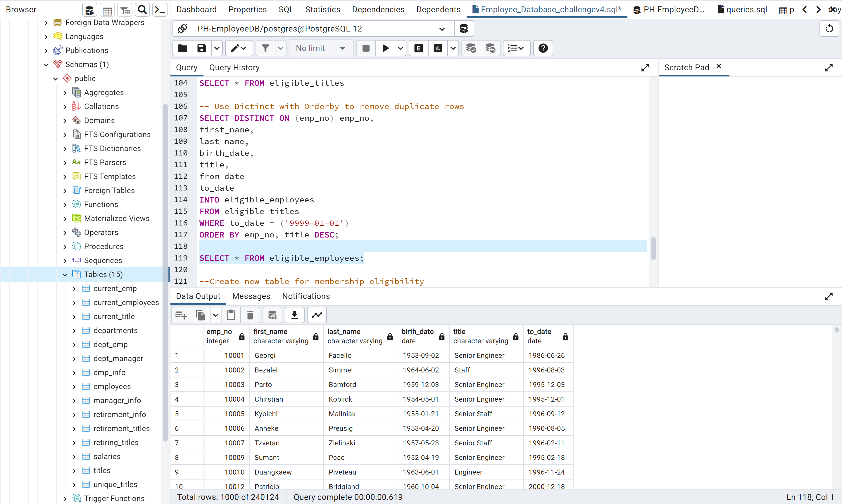

1. Join the Employees and the Department Employee tables on the primary key.
2. Join the Employees and the Titles tables on the primary key.
3. Filter the data on the to_date column to all the current employees, then filter the data on the birth_date columns to get all the employees whose birth dates are between January 1, 1965 and December 31, 1965.
4. Order the table by the employee number.

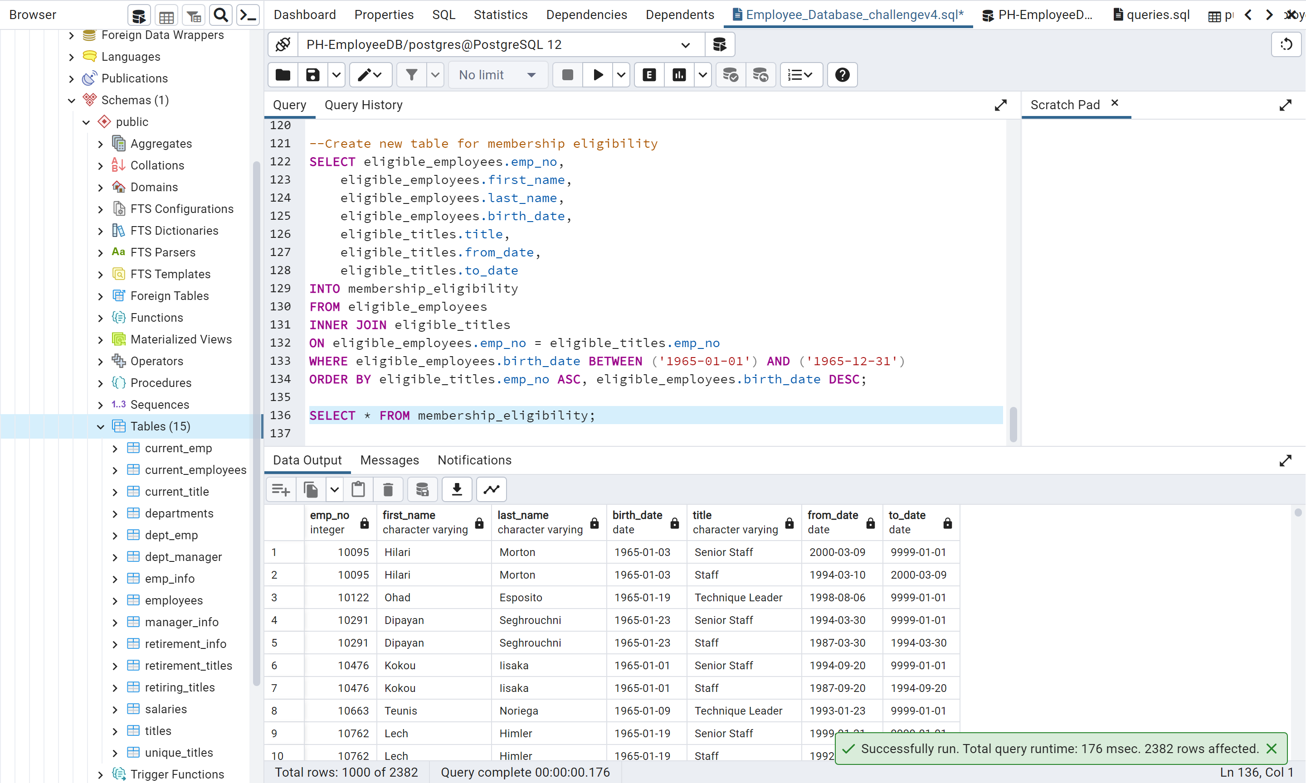

1. Export the Mentorship Eligibility table as mentorship_eligibilty.csv and save it to your Data folder in the Pewlett-Hackard-Analysis folder.

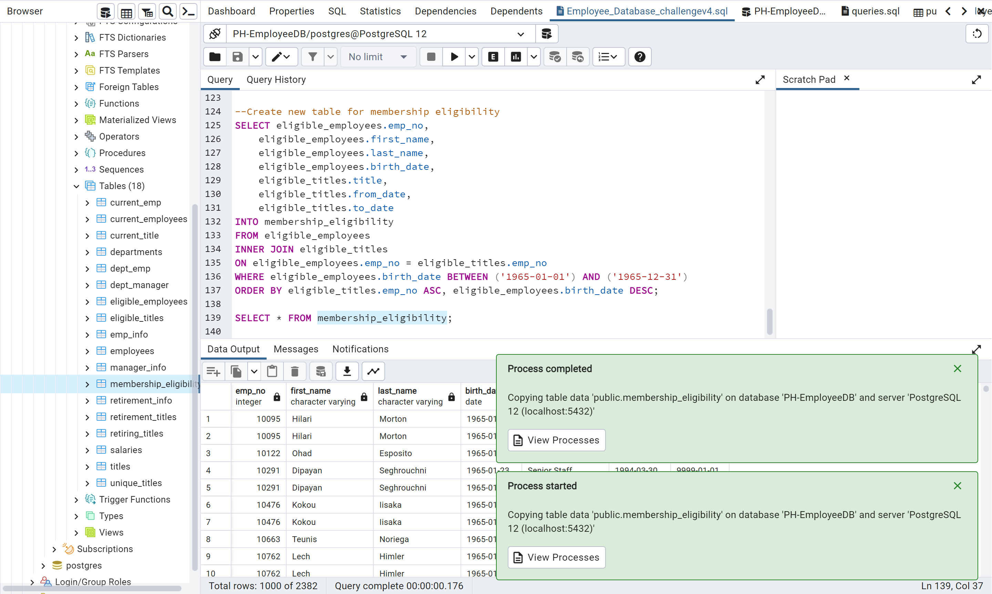

#### Deliverable 3: A written report on the employee database analysis (20 points)

For this part of the Challenge, you’ll write a report to help the manager prepare for the upcoming "silver tsunami."

The analysis should contain the following:

**##Overview of the analysis:** Explain the purpose of this analysis.

(As captured from Data Bootcamp Module 7)

I am the assigned Data Analyst assisting Bobby an HR analyst whose task is to perform employee research. As the Data Analyst, I will be applying my knowledge of DataFrames and tabular data, I will create entity relationship diagrams (ERDs), import data into a database, troubleshoot common errors, and create queries that use data to answer questions.

By the end of this module, as assigned Data Analyst, I will complete the following::

* Design an ERD that will apply to the data.
* Create and use a SQL database.
* Import and export large CSV datasets into pgAdmin.
* Practice using different joins to create new tables in pgAdmin.
* Write basic- to intermediate-level SQL statements.

##Purpose

To determine the number of retiring employees per title, and identify employees who are eligible to participate in a mentorship program. In addition, I will need to determine the current number of employees born between January 1, 1952 and December 31, 1955. This will help to understand how many positions will need to be filled. All employees born within that timeframe are considered for a mentorship program, so employees who are close to retirement age can help prepare other employees to fill their positions.

**##Results:**

 Provide a bulleted list with four major points from the two analysis deliverables. Use images as support where needed.

* At the time of this analysis there are currently 300,024 employees in the company. (As per the deliverable “employees.cvs” )
* There are 1549 unique titles

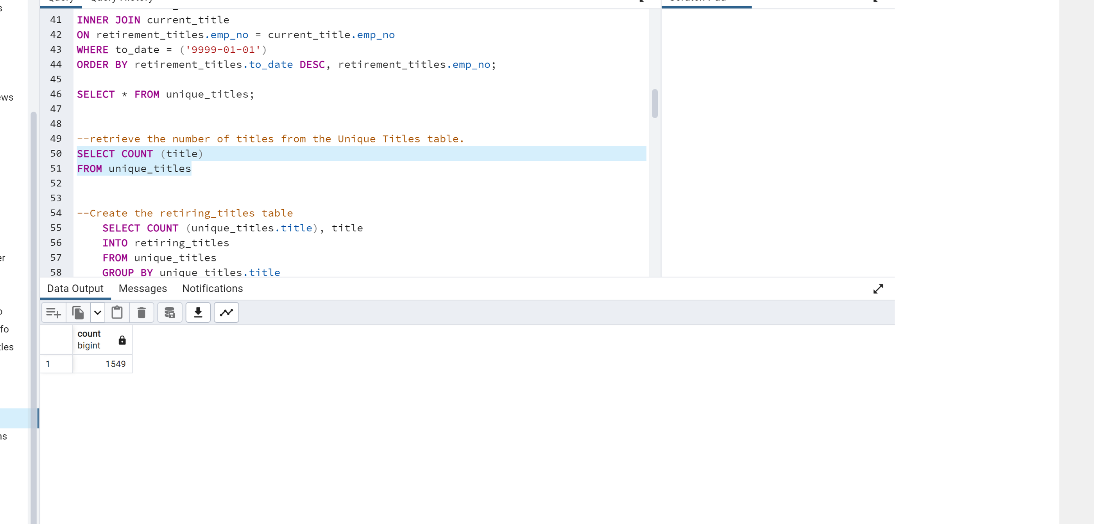

* Where a large majority of the retiring staff are members of Senior Management (As per the deliverable “retiring_titles.cvs”



* Number of eligible employees



Created an initial map of the database, using an online tool called Quick Database Diagrams ("Quick DBD" for short). This map will illustrate each table in the database and the flow of data from one table to another. For this example, as Data Analyst, I have chosen to look at the “emp_no” as the primary key noted in most of the data sets (csv files).

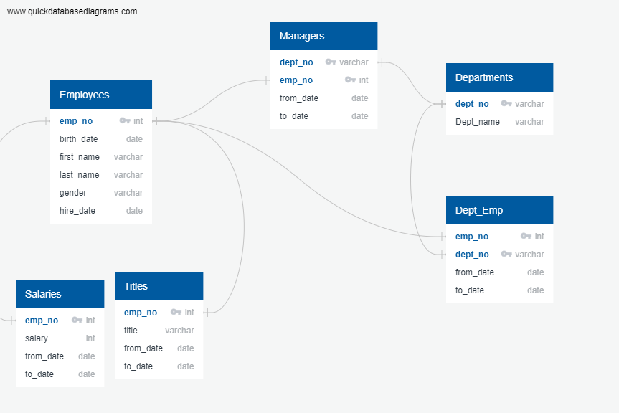

**##Summary:**

 Provide high-level responses to the following questions, then provide two additional queries or tables that may provide more insight into the upcoming "silver tsunami."

* + How many roles will need to be filled as the "silver tsunami" begins to make an impact?

## The Pewlett-Hackard analysis summary

72 458 roles will need to be filled as the "silver tsunami" begins to make an impact for next 3 years. But per year it will be as below on the screen:

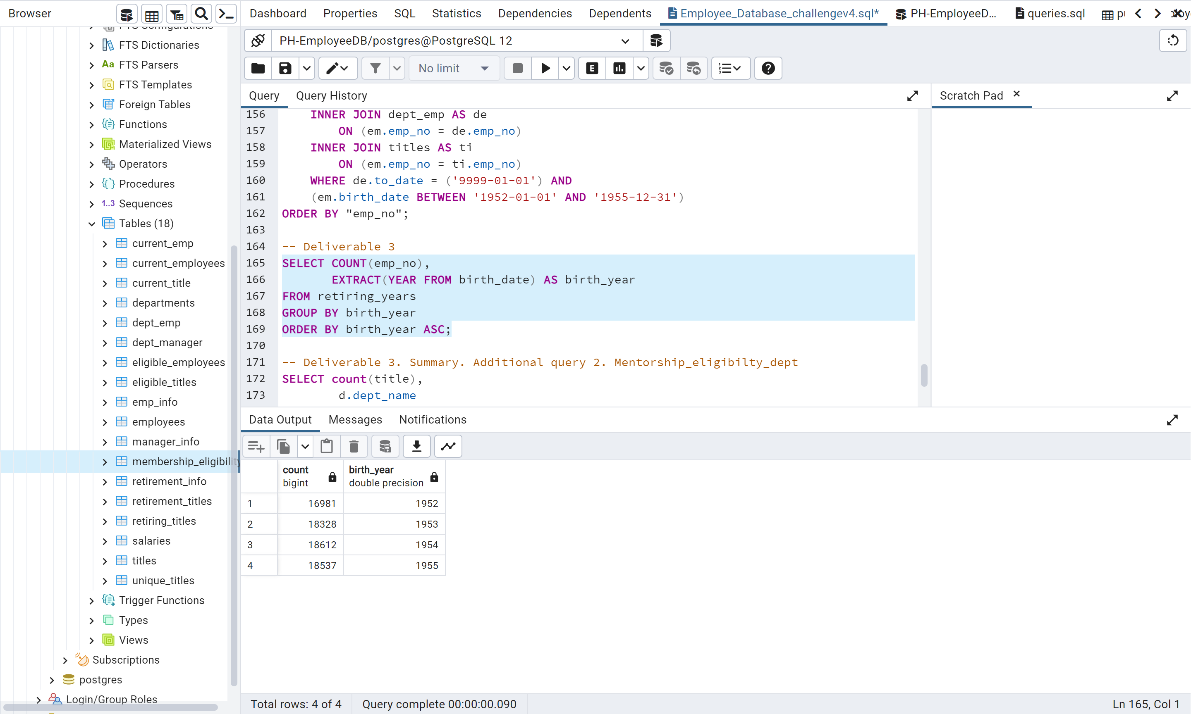

* Are there enough qualified, retirement-ready employees in the departments to mentor the next generation of Pewlett Hackard employees?

c

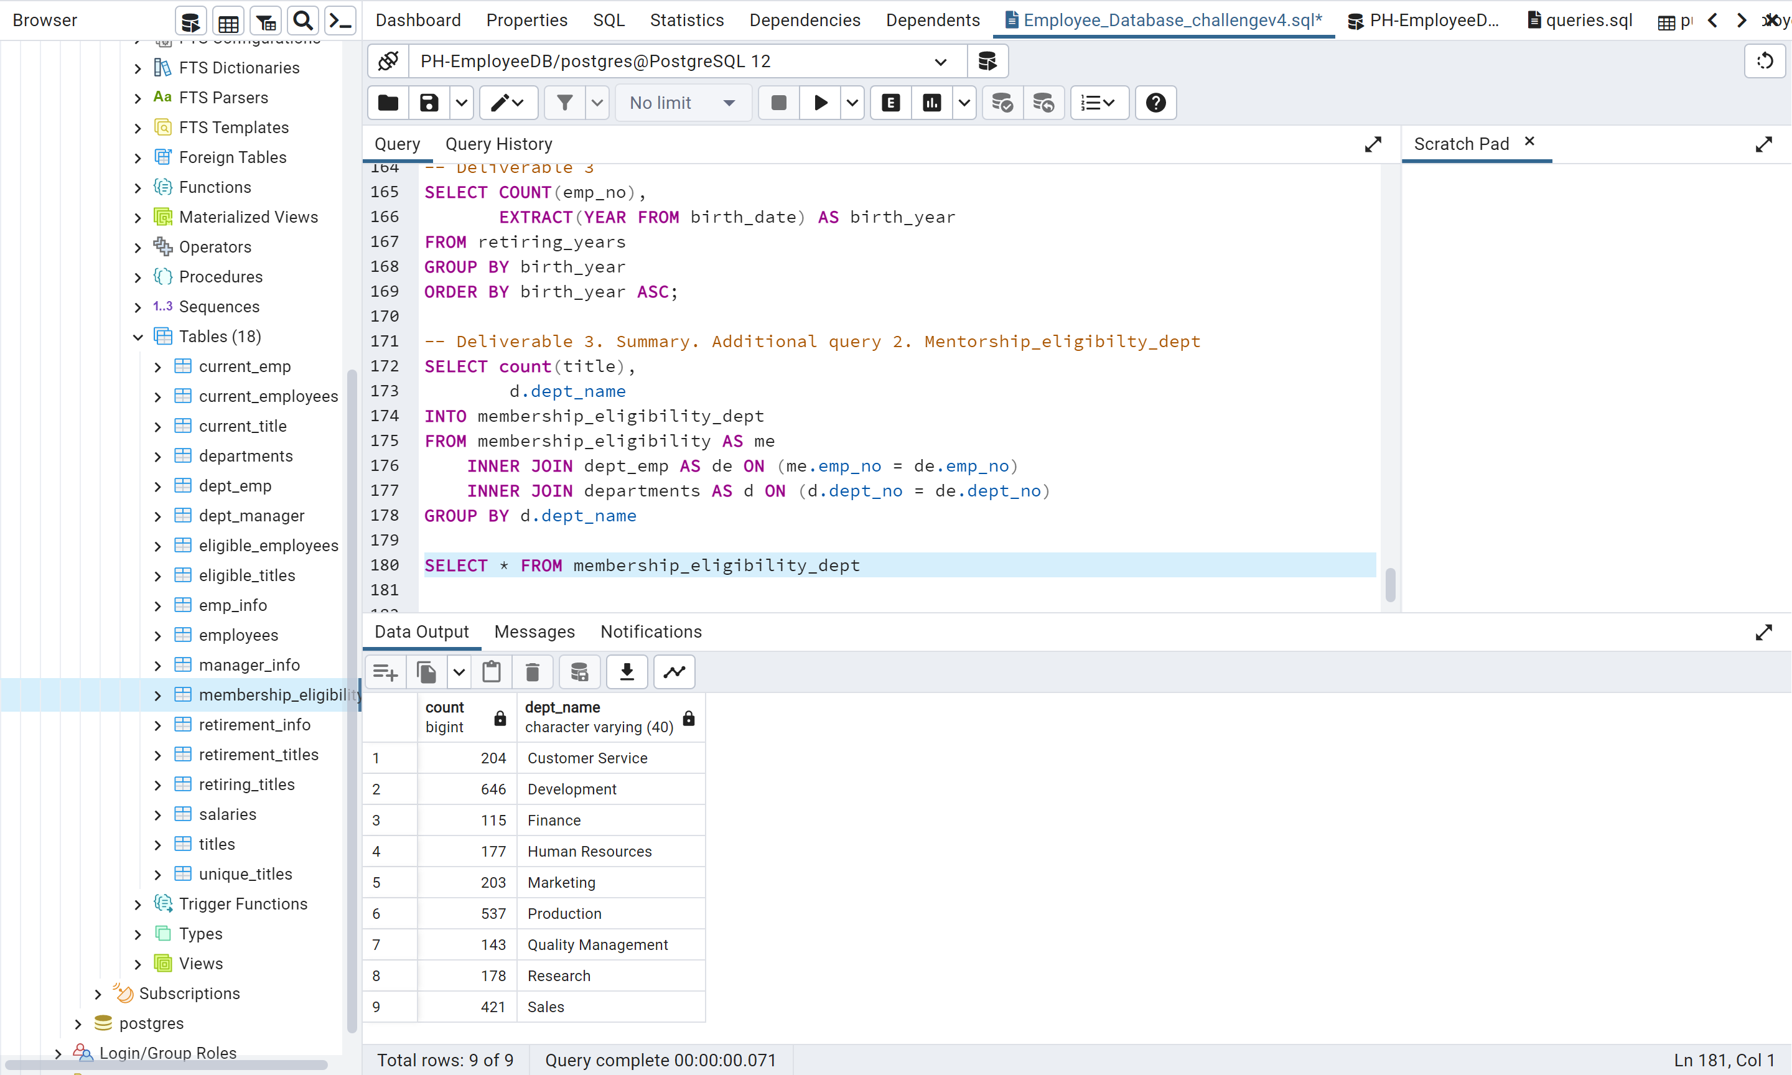

Bobby is an up-and-coming HR analyst whose task is to perform employee research.

**Looking Ahead**

In this module, you'll learn about data modeling, engineering, and analysis. Applying your knowledge of DataFrames and tabular data, you'll create entity relationship diagrams (ERDs), import data into a database, troubleshoot common errors, and create queries that use data to answer questions. Databases are used everywhere—small and large businesses, and even individuals working on personal projects—and SQL is one of the most widely used query languages. Its ability to organize and query data, especially on a large scale, makes SQL knowledge a highly sought after skill in the workforce.

**What You Will Learn**

By the end of this module, you will be able to:

* Design an ERD that will apply to the data.
* Create and use a SQL database.
* Import and export large CSV datasets into pgAdmin.
* Practice using different joins to create new tables in pgAdmin.
* Write basic- to intermediate-level SQL statements.

Bobby is an up-and-coming HR analyst whose task is to perform employee research. Specifically, he needs to find answers to the following questions: Who will be retiring in the next few years? And how many positions will Pewlett Hackard need to fill? This analysis will help future-proof Pewlett Hackard by generating a list of all employees eligible for the retirement package. The employee data Bobby needs is only available in the form of six CSV files because Pewlett Hackard has been mainly using Excel and VBA to work with their data.

But now, they have decided to update their methods to use SQL, a definite upgrade considering the amount of data. Your task is to help Bobby build an employee database with SQL by applying your data modeling, engineering, and analysis skills.

To help Bobby prepare for his analysis, he'll need to download his tools: PostgreSQL and pgAdmin. He'll use Postgres to create a database, and pgAdmin to work with the data he'll be importing. These tools are packaged together in a single download, so let's get started with the setup!

## Database Keys

Database keys identify records from tables and establish relationships between tables. There are numerous types of keys. For our purposes, we will focus on primary keys and foreign keys.

#### Primary Keys

The departments.csv file has a dept_no column with unique identifiers for each row (one department number per department). For example, d001 will always reference the Marketing department, across other worksheets. This unique identifier is known as a **primary key**.

Primary keys are an important part of database design. When a database is being created, each table added must include a primary key in the architecture. Primary keys serve as a link between these tables.

**Entity Relationship Diagrams (ERDs)**

An **entity relationship diagram (ERD)** is a type of flowchart that highlights different tables and their relationships to each other. The ERD does not include any actual data, but it does capture the following pertinent information from each CSV file:

* Primary keys
* Foreign keys
* Data types for each column

The ERD also shows the flow of information from one table to another, as captured in the image below:

In addition to creating new databases, ERDs are used to document existing databases. The visual representation of the tables gives a deeper understanding of the data and the database as a whole.

When creating a diagram, we need to fully understand all of the data being inserted. Datab

Another step is to create a map of the database. This map will show us each table in the database and the flow of data from one table to another. That's right, we're going to make a fancy flowchart. This provides us with an easy reference to the data without actually accessing it. This is called "modeling the data," and we can get started by creating a diagram with an online tool, instead of trying to make one from scratch. Our flow chart will help us navigate through the relationships more easily than if we had all six CSV files open side-by-side.  
  
Using an online tool called Quick Database Diagrams ("Quick DBD" for short), we'll help Bobby start by familiarizing ourselves with the webpage, then create a conceptual ERD.

here are several ways to refer to the map we're about to create. It's also called a flowchart, an entity relationship diagram, and a schema. We'll be using all of these terms in this module, though "ERD" is the most specific.  
  
There are three forms of ERDs: conceptual, logical, and physical. We'll start by helping Bobby with the most basic of the three, the conceptual diagram. As we add more information to our tables, such as data types and keys, we'll advance through the more complex diagrams.

## Conceptual Diagrams

A **conceptual diagram** is an ERD in its simplest form. To create one, we only need two things: a table name and column headers.

weather_api_key="dd4489015a0d53691a4504c482fe26b5"

# Geoapify API Key

geoapify_key = "114208dbe31c49a6aee5748cfdc3a2e5"

### Basic Project Plan

Here's an outline of your project plan:

* **Task:** Collect and analyze weather data across cities worldwide.
* **Purpose:** PlanMyTrip will use the data to recommend ideal hotels based on clients' weather preferences.
* **Method:** Create a Pandas DataFrame with 500 or more of the world's unique cities and their weather data in real time. This process will entail collecting, analyzing, and visualizing the data.

Your analysis of the data will be split into three main parts, or stages.

1. **Collect the Data**
   * Use the NumPy module to generate more than 1,500 random latitudes and longitudes.
   * Use the citipy module to list the nearest city to the latitudes and longitudes.
   * Use the OpenWeatherMap API to request the current weather data from each unique city in your list.
   * Parse the JSON data from the API request.
   * Collect the following data from the JSON file and add it to a DataFrame:
     + City, country, and date
     + Latitude and longitude
     + Maximum temperature
     + Humidity
     + Cloudiness
     + Wind speed
2. **Exploratory Analysis with Visualization**
   * Create scatter plots of the weather data for the following comparisons:
     + Latitude versus temperature
     + Latitude versus humidity
     + Latitude versus cloudiness
     + Latitude versus wind speed
   * Determine the correlations for the following weather data:
     + Latitude and temperature
     + Latitude and humidity
     + Latitude and cloudiness
     + Latitude and wind speed
   * Create a series of maps using GeoViews and the Geoapify API that showcases the following:
     + Latitude and temperature
     + Latitude and humidity
     + Latitude and cloudiness
     + Latitude and wind speed
3. **Visualize Travel Data**

Create a map can display information on specific cities based on a customer's travel preferences. Complete these steps:

* + Filter the Pandas DataFrame based on user inputs for a minimum and maximum temperature.
  + Create a map for the new DataFrame.
  + Find a hotel from the cities' coordinates using the Geoapify API.
  + Store the name of the first hotel in the DataFrame.
  + Add additional information to each point in the map that display information about the city, current maximum temperature, and a hotel in the city.

ownload his tools: PostgreSQL and pgAdmin.

**PostgreSQL**

PostgreSQL, typically referred to as just "Postgres," is a **relational database system**. This type of database consists of tables and their predefined relationships.

Think of it like this: Each CSV file's data will be loaded into a table. If there are six CSV files, then there will also be six tables in Postgres. "Relationships" are how each table relates to another. We'll create tables and define relationships as we progress through the module, so don't worry if this seems confusing right now—we'll get lots of practice.

Another aspect of Postgres is that it will create a local server on your computer, which is where the databases we create will be stored. Then the databases will store the tables and the data. It's a rather intricate filing system.

**NOTE**

For more about PostgreSQL, see the [PostgreSQL documentationLinks to an external site.](https://www.postgresql.org/docs/manuals/) and the [PostgreSQL tutorialLinks to an external site.](https://www.tutorialspoint.com/postgresql/).

**pgAdmin**

pgAdmin is the window into our database: it's where queries are written and executed and where results are viewed. While Postgres holds the files, pgAdmin provides the access. All SQL actions take place within these two programs, so let's install them.

Another crucial part of getting a database ready is preparing a solid foundation. We're doing part of that by familiarizing ourselves with the data, but how will it be represented in SQL?  SQL organizes data into tables, and each CSV's data will live in its own table: six CSV files will mean six SQL tables. Let's look more into these tables and their properties.

large chunk of data modeling! Understanding the data we're working with and finding the connections within is a huge step.  
  
Another step is to create a map of the database. This map will show us each table in the database and the flow of data from one table to another. That's right, we're going to make a fancy flowchart. This provides us with an easy reference to the data without actually accessing it. This is called "modeling the data," and we can get started by creating a diagram with an online tool, instead of trying to make one from scratch. Our flow chart will help us navigate through the relationships more easily than if we had all six CSV files open side-by-side.  
  
Using an online tool called Quick Database Diagrams ("Quick DBD" for short), we'll help Bobby start by familiarizing ourselves with the webpage, then create a conceptual ERD.

Using our final ERD as a guide, we'll create six tables, one for each CSV file. During the creation, we'll even map out the primary and foreign keys and assign data types. This will all be completed using pgAdmin's query editor, which is a code editor for SQL, much like VS Code is for Python.

## Troubleshoot Error Messages

Any error message will also appear in the same manner. Encountering errors will happen often and troubleshooting them is a large part of being a developer. Thankfully, each error message encountered will tell us why the error occurred. This is great because it helps us, the developers, research and fix the problem.

Practice troubleshooting an error by executing the code to create the departments table again. After running the exact same code again, you'll get this error message:

This error occurs because SQL data is persistent and cannot be overwritten if the same command is run again. Once a table has been committed to a database, it is there until a different command is run to delete it.

**Alright,** we've created a database. We've written our first SQL code and created tables modeled after our ERD. Bobby is almost ready to begin his analysis. The next step is to import the data from the CSV files. We'll make sure all of the tables we created in pgAdmin appear in the GUI first, because we'll be using the GUI to import data.

The best solution is to delete the current, unusable table using the DROP TABLE statement, then create a new one with updated code.

**Drop a Table**

To drop the table, the following code is used:

DROP TABLE employees CASCADE;

* **DROP TABLE employees** tells Postgres that we want to remove the Employees table from the database completely.
* CASCADE; indicates that we also want to remove the connections to other tables in the database.

**IMPORTANT**

The next part is to perform the analysis he was tasked with: future-proofing the company by determining how many people will be retiring and, of those employees, who is eligible for a retirement package.

In Excel, use the hotkey to move to the bottom of the spreadsheet (Command + down arrow for a Mac, or CTRL + down arrow for Windows).

**Pewlett-Hackard-Analysis**

Merging DataFrames in Pandas is very similar to joining tables in SQL. There are several different types of joins and each one will yield a different result. We'll cover each type of join available in SQL as well as where and when to use it.

## Recreate the retirement_info Table with the emp_no Column

DROP TABLE retirement_info CASCADE;

Not quite. This will drop the table completely with no issues, but the CASCADE constraint isn’t necessary. This is because we originally created this table from a query and we hadn’t formed any connections to other tables.

--in order to reload a table you have to Drop it and then re instate it

DROP TABLE retirement_info;

With out CASCADE

## Use Inner Join for Departments and dept-manager Tables

Let's create a query that will return each department name from the Departments table as well as the employee numbers and the from- and to- dates from the dept_manager table. We'll use an inner join because we want all of the matching rows from both tables.

The code for our inner join would look like the following:

**Use Left Join to Capture retirement-info Table**

We'll need to help Bobby recreate this list. Think about what we need to have a fully accurate retirement_info table:

* Employee number
* Employee name (first and last)
* If the person is presently employed with PH

Because of the number of people leaving each department, the boss has requested three lists that are more specific:

1. **Employee Information:** A list of employees containing their unique employee number, their last name, first name, gender, and salary
2. **Management:** A list of managers for each department, including the department number, name, and the manager's employee number, last name, first name, and the starting and ending employment dates
3. **Department Retirees:** An updated current_emp list that includes everything it currently has, but also the employee's departments

Get started with the first list.

Here's everything we need:

1. Employee number
2. First name
3. Last name
4. Gender
5. to_date
6. Salary